

**INTERNSHIP CERTIFICATE**



**ACKNOWLEDGEMENT**

I wish to express my sincere gratitude to my **External guide** **Ms. Sweety Patel** for continuously guiding me at the company and answering all my doubts with patience. I would also like to thank **Dr. Gayatri Pandi (H.O.D. of IT Department)** for motivating me every time whenever I get confused, I would also like to thank my **Internal Guide Mr. Mohit Patel** for helping me through my internship by giving me the necessary suggestions and advices along with their valuable co-ordination in completing this Internship.

I also thank my parents, friends and all the members of the family for their precious support and encouragement which they had provided in completion of my work. In addition to that, I would also like to mention the company personals who gave me the permission to use and experience the valuable resources required for the Internship.

Thus, in conclusion to the above said, I once again thank the staff members of **Tatvasoft** for their valuable support in completion of the Internship.

Thank You

|  |  |  |
| --- | --- | --- |
| **Name of Student**  Vohra MohmmedAtaa Firoz  **Enrollment Number: 201430116048** | **Date:**    **Signature of Student** |  |

**TABLE OF CONTENTS**

|  |  |
| --- | --- |
| **CHAPTERS** | **PAGE NO.** |
| **Title Page** | **i** |
| **Certificate Page** | **ii** |
| **Internship Certificate** | **iii** |
| **Declaration** | **iv** |
| **Acknowledgements** | **v** |
| **Table of Contents** | **vi** |
| **Abstract** | **ix** |
| **List of Figure’s** | **x** |
| **List of Table’s** | **xi** |
| **CHAPTER 1 INTRODUCTION OF PROJECT & COMPANY PROFILE** | **01** |
| 1.1 Introduction |  |
| 1.1.1 Company Profile |  |
| 1.1.2 Company Products |  |
| 1.1.3Company Mission and Vision |  |
| 1.2 Introduction of the Project |  |
| 1.2.1 Purpose of the Project |  |
| 1.2.2 Function Requirements |  |
| 1.2.3 Problems in Existing System |  |
| 1.2.4 Main Modules |  |
| **CHAPTER 2 SYSTEM REQUIREMENTS** | **05** |
| 2.1 Hardware & Software Requirements |  |
| 2.1.1 Server-Side Requirements |  |
| 2.1.2 Developer Side Requirements |  |
| 2.1.3 User Side Requirements |  |
| **CHAPTER 3 WORK SHEET REPORT** | **08** |
| 3.1 WORK SHEET REPORT (15 DAYS) |  |
| **CHAPTER 4 FRONT END OF SYSTEM** | **17** |
| 4.1 About Front End |  |
| 4.1.1 about HTML |  |
| 4.1.2 about CSS |  |
| 4.1.3 about JavaScript |  |
| 4.2 Why Use PHP |  |
| **CHAPTER 5 BACK END OF SYSTEM** | **26** |
| 5.1 About PHP |  |
| 5.2 Why Use PHP |  |
| 5.3 About Back End |  |
| 5.3.1 about MySQL |  |
| 5.3.2 How MySQL Works |  |
| 5.3.3 MySQL Features |  |
| 5.4 Why use MySQL |  |
| **CHAPTER 6 SYSTEM DESIGN** | **33** |
| 6.1 Use Case Diagram |  |
| 6.2 Class Diagram |  |
| **CHAPTER 7 DATA DICTIONARY** | **44** |
| 7.1 **Introduction** |  |
| 7.2 **List of Tables** |  |
| 7.2.1: user_master |  |
| 7.2.2: bakery_info |  |
| 7.2.3: product_category_master |  |
| 7.2.4: product_master |  |
| 7.2.5: booking_master |  |
| 7.2. 6: delivery_boy |  |
| 7.2.7: social_media |  |
| 7.2.8: payment_method |  |
| 7.2.9: state_ master |  |
| 7.2.10: city_master |  |
| 7.2.11: area_master |  |
| 7.2.12: banner_master |  |
| 7.2.13: feedback_master |  |
| 7.2.14: contact_us_master |  |
| 7.2.15: offer_master |  |
| **CHAPTER 8 TESTING** | **55** |
| 8.1 Testing Plan |  |
| 8.2 Testing Strategies |  |
| 8.3 Testing Method |  |
| 8.4 Test Case |  |
| **CHAPTER 9 SNAPSHOT OF WEBSITE** | **61** |
| 9.1 Admin Site |  |
| 9.2 Users Site |  |
| **CHAPTER 10 ADVANTAGES** | **76** |
| 10.1 Advantages |  |
| 10.2 Limitations |  |
| **CHAPTER 11 CONCLUSION AND FUTURE ENHANCEMENT** | **78** |
| 11.1 Conclusion |  |
| 11.2 Future Enhancement |  |
| **CHAPTER 12 BIBLIOGRAPHY** | **80** |
| 12.1 Course Outcome |  |
| 12.2 Books |  |
| 12.2 Web Reference |  |

**ABSTRACT**

MediSync is an innovative online platform dedicated to providing Doctors consultation and Diagnostics services. Serving as a pivotal health-care website, MediSync empowers doctors to elevate patient care and streamline their professional workflows. With a user-friendly interface, it simplifies various tasks for physicians, allowing seamless access to patient records, efficient appointment management, and secure communication channels with patients. Patients benefit from the platform by easily requesting care for themselves or others. MediSync caters to three user categories: Admin, Physician, and Patients. Admin users enjoy comprehensive access to patient and physician records, enabling thorough review of patient history, effective case management, and the authority to manage requests by canceling or blocking them when deemed necessary.

**LIST OF FIGURES**

|  |  |
| --- | --- |
| **FIGURE NAME** | **PAGE NO.** |
|  |  |
| **FIGURE NAME 1(Figure 1.1: Figure name)** | **25** |
| **FIGURE NAME 2** | **26** |
|  |  |
|  |  |
|  |  |
|  |  |
|  |  |
|  |  |
|  |  |

**LIST OF TABLES**

|  |  |
| --- | --- |
| **TABLE NAME** | **PAGE NO.** |
|  |  |
| **TABLE NAME 1(Table 1.1: Table name)** | **10** |
| **TABLE NAME 2** | **20** |
|  |  |
|  |  |
|  |  |
|  |  |
|  |  |
|  |  |

**CHAPTER: 1**

**INTRODUCTION**

* 1. **Introduction**
     1. **Company Profile**
     2. **Company Products**
     3. **Company Mission and Vision**
  2. **Introduction of the Project**
     1. **Purpose of the Project**
     2. **Function Requirements**
     3. **Problem in Existing System**
     4. **Main Modules**

**1.2 Introduction of the Project**

**1.2.1 Purpose of the Project**

The purpose of the Medisync project is to develop a comprehensive online platform dedicated to facilitating Doctor consultations and Diagnostics services. It aims to streamline healthcare processes by providing doctors with efficient tools to manage patient records, appointments, and communications securely. Additionally, it seeks to enhance the patient experience by enabling easy access to care requests and relevant healthcare information.

**1.2.2 Function Requirements**

The functional requirements of the Medisync project include:

* User authentication and login functionality for Admin, Physicians, and Patients.
* Admin dashboard with features for managing patient and physician records, cases, appointments, and requests.
* Physician dashboard allowing for the management of patient encounters, cases, and requests.
* Patient site offering the ability to submit various types of healthcare requests and access relevant information.
* Secure communication channels between doctors and patients.
* Comprehensive search functionality for accessing patient records.
* Logging and tracking features for monitoring system activities and history.
* Integration with diagnostic services and external partners/vendors.
* User profile management for maintaining personal and professional information.
* Support and helpdesk features for addressing user inquiries and issues.
  + 1. **Problem in Existing System**

The existing healthcare system may face several challenges such as:

* Fragmented patient records and inefficient communication channels between doctors and patients.
* Manual appointment scheduling processes leading to delays and errors.
* Lack of a centralized platform for managing healthcare requests and cases.
* Limited accessibility to healthcare services, especially for remote patients.
* Security concerns regarding patient data privacy and confidentiality.
* Difficulty in tracking and monitoring system activities and user interactions.

**1.2.4. Main Modules**

The main modules of the Medisync project include:

* + Platform Authentication and User Management: This module handles user registration, login, and profile management for Admin, Physicians, and Patients.
  + Admin Dashboard: Provides features for managing patient and physician records, appointments, requests, and system settings.
  + Physician Dashboard: Allows physicians to manage patient encounters, cases, appointments, and communication with patients.
  + Patient Site: Offers patients the ability to submit various types of healthcare requests, access health information, and communicate with doctors.
  + Diagnostic Services Integration: Module for integrating diagnostic services and managing orders and results.
  + Logging and Monitoring: Tracks system activities, logs user interactions, and maintains audit trails for security and accountability.
  + Helpdesk and Support: Provides assistance and support for users through a dedicated helpdesk system.

**CHAPTER 2 SYSTEM REQUIREMENTS**

**2.1 Hardware & Software Requirements**

**2.1.1 Server-Side Requirements**

* + Operating System: Linux-based OS (e.g., Ubuntu Server)
  + Processor: Multi-core processor (e.g., Intel Xeon or AMD Ryzen)
  + Memory: Minimum 2GB RAM (4GB or higher recommended)
  + Storage: Sufficient disk space for storing application files, databases, and logs (minimum 20GB SSD recommended)
  + Network: Stable internet connection with sufficient bandwidth for handling API requests and data transfer
  + Database: MongoDB (or any other preferred database system)
  + Node.js: Latest LTS version installed on the server

**2.1.2 Developer Side Requirements**

* + Operating System: Windows, macOS, or Linux
  + IDE: Visual Studio Code (recommended), with necessary extensions for React.js, TypeScript, and Node.js development
  + Node.js: Latest LTS version installed on the development machine
  + Package Manager: npm (comes with Node.js installation) or Yarn for managing dependencies
  + Version Control: Git installed on the development machine for version control and collaboration
  + Postman: Installed for testing and debugging APIs
  + Browser: Latest version of Google Chrome, Mozilla Firefox, or Microsoft Edge for testing web applications
  + Graphics: Optional, but a good graphics card may be helpful for running development tools smoothly

**2.1.3 User Side Requirements**

* + Operating System: Compatible with major operating systems (Windows, macOS, Linux)
  + Web Browser: Latest versions of Google Chrome, Mozilla Firefox, Microsoft Edge, or Safari for accessing the web application
  + Internet Connection: Stable internet connection with sufficient bandwidth for accessing the web application and making API requests
  + Hardware: Standard computer or mobile device capable of running modern web applications without significant performance issues

**CHAPTER: 3**

**Daily Task**

**3.1 Work Sheet Report**

**3.1.1 Work Sheet Report (15 Days)**

**3.1.2 Work Sheet Report (15 Days)**

**3.1.3 Work Sheet Report (15 Days)**

**3.1 Work Sheet Report (15 DAYS):**

|  |  |  |  |  |  |
| --- | --- | --- | --- | --- | --- |
| **SUGGESTED 15 DAYS WORK SHEET REPORT** | | | | | |
| Student Name: | | |  | | |
| Enrollment No: | | |  | | |
| Internship/Project Title | | |  | | |
| Tools and Technologies | | |  | | |
| Company/ Organization Name | | |  | | |
| Student’s Activity Details: | | | | | |
| **Week**  **Number** | **Start Date to**  **End Date** | **Tasks to be assigned** | | **Tasks to be completed** | **Remarks** |
|  |  |  | |  |  |
|  |  |  | |  |  |

|  |  |  |  |  |  |
| --- | --- | --- | --- | --- | --- |
| **SUGGESTED 15 DAYS WORK SHEET REPORT** | | | | | |
| Student Name: | | |  | | |
| Enrollment No: | | |  | | |
| Internship/Project Title | | |  | | |
| Tools and Technologies | | |  | | |
| Company/ Organization Name | | |  | | |
| Student’s Activity Details: | | | | | |
| **Week**  **Number** | **Start Date to**  **End Date** | **Tasks to be assigned** | | **Tasks to be completed** | **Remarks** |
|  |  |  | |  |  |
|  |  |  | |  |  |

|  |  |  |  |  |  |
| --- | --- | --- | --- | --- | --- |
| **SUGGESTED 15 DAYS WORK SHEET REPORT** | | | | | |
| Student Name: | | |  | | |
| Enrollment No: | | |  | | |
| Internship/Project Title | | |  | | |
| Tools and Technologies | | |  | | |
| Company/ Organization Name | | |  | | |
| Student’s Activity Details: | | | | | |
| **Week**  **Number** | **Start Date to**  **End Date** | **Tasks to be assigned** | | **Tasks to be completed** | **Remarks** |
|  |  |  | |  |  |
|  |  |  | |  |  |

|  |  |  |  |  |  |
| --- | --- | --- | --- | --- | --- |
| **SUGGESTED 15 DAYS WORK SHEET REPORT** | | | | | |
| Student Name: | | |  | | |
| Enrollment No: | | |  | | |
| Internship/Project Title | | |  | | |
| Tools and Technologies | | |  | | |
| Company/ Organization Name | | |  | | |
| Student’s Activity Details: | | | | | |
| **Week**  **Number** | **Start Date to**  **End Date** | **Tasks to be assigned** | | **Tasks to be completed** | **Remarks** |
|  |  |  | |  |  |
|  |  |  | |  |  |

|  |  |  |  |  |  |
| --- | --- | --- | --- | --- | --- |
| **SUGGESTED 15 DAYS WORK SHEET REPORT** | | | | | |
| Student Name: | | |  | | |
| Enrollment No: | | |  | | |
| Internship/Project Title | | |  | | |
| Tools and Technologies | | |  | | |
| Company/ Organization Name | | |  | | |
| Student’s Activity Details: | | | | | |
| **Week**  **Number** | **Start Date to**  **End Date** | **Tasks to be assigned** | | **Tasks to be completed** | **Remarks** |
|  |  |  | |  |  |
|  |  |  | |  |  |

|  |  |  |  |  |  |
| --- | --- | --- | --- | --- | --- |
| **SUGGESTED 15 DAYS WORK SHEET REPORT** | | | | | |
| Student Name: | | |  | | |
| Enrollment No: | | |  | | |
| Internship/Project Title | | |  | | |
| Tools and Technologies | | |  | | |
| Company/ Organization Name | | |  | | |
| Student’s Activity Details: | | | | | |
| **Week**  **Number** | **Start Date to**  **End Date** | **Tasks to be assigned** | | **Tasks to be completed** | **Remarks** |
|  |  |  | |  |  |
|  |  |  | |  |  |

**CHAPTER 4: FRONT END OF SYSTEM**

**4.1 About Front End**

The front end of the MediSync system is developed using React.js, a popular JavaScript library for building user interfaces. React.js allows for the creation of dynamic and interactive web applications with reusable components. The front end serves as the interface through which users interact with the system, including doctors, patients, and administrators.

Key features of the front end include:

* + User-friendly interface design to facilitate ease of navigation and interaction.
  + Responsive layout to ensure compatibility across various devices, including desktops, tablets, and mobile phones.
  + Integration with Redux for state management, enabling efficient data flow and application-wide state handling.
  + Implementation of TypeScript for enhanced code readability, scalability, and type safety.
  + Utilization of modern UI/UX design principles to enhance user experience and satisfaction.
  + Seamless integration with backend APIs to fetch and display relevant data in real-time.
  + Implementation of authentication and authorization mechanisms to ensure secure access to system functionalities based on user roles.
  + Support for internationalization and localization to cater to users from different regions and languages.

Hence, The front end plays a crucial role in providing a visually appealing, intuitive, and efficient user experience for all stakeholders involved in the MediSync system. It aims to streamline workflows, enhance productivity, and improve overall satisfaction with the healthcare platform.

**CHAPTER 5: BACK END OF SYSTEM**

**5.1 About Back-End**

Node.js, TypeScript, and Express form the backbone of the back end architecture for the MediSync system.

Node.js is a runtime environment that allows developers to run JavaScript on the server-side. It provides an event-driven, non-blocking I/O model that makes it lightweight and efficient, ideal for building scalable and high-performance web applications.

TypeScript is a superset of JavaScript that adds static typing and other features to the language, enhancing code quality, maintainability, and scalability. TypeScript allows developers to catch errors early in the development process and write more robust and predictable code.

Express is a minimalist web framework for Node.js that simplifies the process of building web applications and APIs. It provides a robust set of features for handling HTTP requests, routing, middleware, and more, allowing developers to create powerful and scalable back end services with ease.

**5.2 Why Use Node.js**

Node.js is chosen for the back end of the MediSync system due to several reasons:

* + JavaScript is a widely-used language, allowing for full-stack development with a single language.
  + Non-blocking I/O model provides high concurrency and scalability, making it suitable for handling large volumes of concurrent requests.
  + Rich ecosystem of npm modules for rapid development and easy integration of third-party libraries.
  + Event-driven architecture enables real-time communication and responsiveness in web applications.
  + Lightweight and efficient runtime, making it well-suited for microservices and cloud-based architectures.

**5.3 About Back End**

The back end of the MediSync system is responsible for handling data storage, processing, and retrieval, as well as implementing business logic and application functionality.

5.3.1 About MySQL

MySQL is chosen as the relational database management system (RDBMS) for storing and managing data in the MediSync system. It is an open-source database system known for its reliability, scalability, and performance.

5.3.2 How MySQL Works

MySQL operates on a client-server architecture, where client applications connect to the MySQL server to perform database operations. It uses Structured Query Language (SQL) for querying and manipulating data stored in relational tables.

5.3.3 MySQL Features

Key features of MySQL include:

* + ACID compliance, ensuring data integrity and transaction reliability.
  + Support for various storage engines, including InnoDB, MyISAM, and Memory.
  + Scalability options such as replication, clustering, and partitioning.
  + Security features including encryption, authentication, and access control.

**5.4 Why Use MySQL**

MySQL is selected for the MediSync system backend due to the following reasons:

* + Mature and widely adopted database system with a large community and extensive documentation.
  + Robust features for data management, transactions, and performance optimization.
  + Compatibility with various programming languages, frameworks, and platforms.
  + Cost-effective solution with open-source licensing options.
  + Integration with other tools and technologies commonly used in the web development ecosystem.

MySQL provides a reliable and scalable data storage solution for the MediSync system, ensuring efficient management and retrieval of healthcare-related information.

**CHAPTER: 6**

**SYSTEM DESIGN**

**6.1 Use Case Diagram**

* 1. **Class Diagram**

**6.1 Use Case Diagram**

A use case diagram is used to represent the dynamic behavior of a system. It encapsulates the system's functionality by incorporating use cases, actors, and their relationships.

It models the tasks, services, and functions required by a system/subsystem of an application. It depicts the high-level functionality of a system and also tells how the user handles a system.

* **Purpose of Use Case Diagrams**

The main purpose of a use case diagram is to portray the dynamic aspect of a system. It accumulates the system's requirement, which includes both internal as well as external influences. It invokes persons, use cases, and several things that invoke the actors and elements accountable for the implementation of use case diagrams.

* + It gathers the system's needs.
  + It depicts the external view of the system.
  + It recognizes the internal as well as external factors that influence the system.
  + It represents the interaction between the actors.

**Symbols used in Use case:**

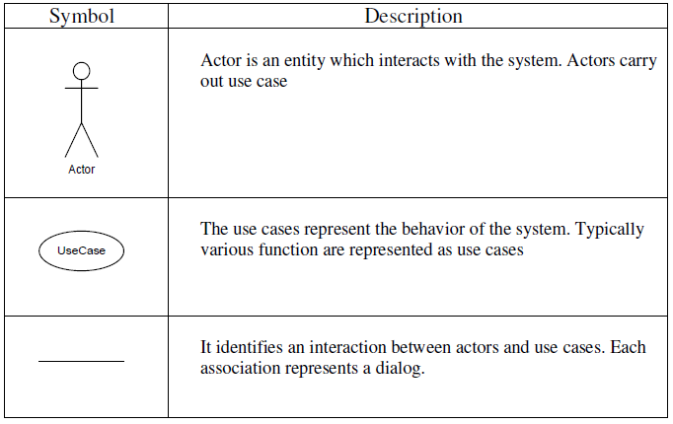

* + 1. **Use case Diagram :-**



**Figure 6.2.1 Use Case diagram**

**CHAPTER: 7**

**DATA DICTIONARY**

**7.1 Introduction**

**7.2 List of Tables**

**7.2.1: user_master**

**7.2.2: bakery_info**

**7.2.3: product_category_master**

**7.2.4: product_master**

**7.1 Introduction**

Data Dictionary is an important part of a project or system which contains all definition of elements in the system. In Data Dictionary you will find a list of all elements composing the data flowing through a system.

* The major elements of a system:
  + Data Flow
  + Data Store
  + Processes
* The data dictionary stores all details and description of these elements.
* The data dictionary provides additional information about the system.
* The data dictionary contains the data about data e.g. Student is a data and this student belongs to this course is a description of STUDENT data which is stored in data dictionary.
* Why is Data Dictionary important?
  + To manage the details in large system.
  + To communicate a common meaning for all system elements.
  + To document the features of system.
  + To determine where system changes should made.
  + To locate errors and omissions in the system.

**7.2 List of Tables:**

* **Table 7.2.1: user**

**Primary key: user_id**

**Foreign key: role_id**

**[Table 7.2.1: User table]**

|  |  |  |  |
| --- | --- | --- | --- |
| **Column** | **Type** | **Null** | **Default** |
| **user_id** | int | No |  |
| **username** | varchar(255) | Yes | NULL |
| **email** | varchar(255) | Yes | NULL |
| password | varchar(255) | Yes | NULL |
| type_of_user | enum(admin, patient,physician) | No |  |
| firstname | varchar(255) | No |  |
| lastname | varchar(255) | No |  |
| **mobile_no** | bigint | Yes | NULL |
| reset_token | varchar(255) | Yes | NULL |
| reset_token_expiry | bigint | Yes | NULL |
| address_1 | varchar(255) | Yes | NULL |
| address_2 | varchar(255) | Yes | NULL |
| city | varchar(255) | Yes | NULL |
| state | varchar(255) | Yes | NULL |
| country_code | varchar(255) | Yes | NULL |
| zip | int | Yes | NULL |
| role_id | int | Yes | NULL |
| status | enum(active, pending, in-active) | No | pending |
| **billing_mobile_no** | bigint | Yes | NULL |
| dob | datetime | Yes | NULL |
| medical_licence | varchar(255) | Yes | NULL |
| NPI_no | int | Yes | NULL |
| **alternative_mobile_no** | bigint | Yes | NULL |
| stop_notification_status | enum(yes, no) | Yes | no |
| **synchronization_email** | varchar(255) | Yes | NULL |
| admin_notes | varchar(255) | Yes | NULL |
| street | varchar(255) | Yes | NULL |
| open_requests | int | Yes | 0 |
| business_name | varchar(255) | Yes | NULL |
| tax_id | varchar(255) | Yes | NULL |
| business_website | varchar(255) | Yes | NULL |
| profile_picture | varchar(255) | Yes | NULL |
| signature_photo | varchar(255) | Yes | NULL |
| on_call_status | enum(yes, no) | Yes | NULL |
| support_message | varchar(255) | Yes | NULL |
| createdAt | datetime | Yes | NULL |
| updatedAt | datetime | Yes | NULL |

* **Table 7.2.2: request**

**Primary key: request_id**

**[Table 7.2.2: Request table]**

|  |  |  |  |
| --- | --- | --- | --- |
| **Column** | **Type** | **Null** | **Default** |
| **request_id** | int | No |  |
| **confirmation_no** | varchar(255) | No |  |
| request_state | enum(new, active, pending, conclude, toclose, unpaid) | No |  |
| patient_id | int | Yes | NULL |
| physician_id | int | Yes | NULL |
| requested_by | enum(family/friend, concierge, business, vip, admin, patient, provider) | No |  |
| requestor_id | int | Yes | NULL |
| requested_date | datetime | Yes | NULL |
| concluded_date | datetime | Yes | NULL |
| date_of_service | datetime | Yes | NULL |
| closed_date | datetime | Yes | NULL |
| request_status | enum(unassigned, assigned, accepted, closed, conclude, blocked, clear, cancelled by admin, cancelled by provider) | No | unassigned |
| block_reason | varchar(255) | Yes | NULL |
| agreement_status | enum(pending, accepted, rejected) | Yes | NULL |
| notes_symptoms | varchar(255) | Yes | NULL |
| assign_req_description | varchar(255) | Yes | NULL |
| final_report | varchar(255) | Yes | NULL |
| createdAt | datetime | Yes | NULL |
| updatedAt | datetime | No |  |

* **Table 7.2.3: requestor**

**Primary key: user_id**

**[Table 7.2.3: Requestor table]**

|  |  |  |  |
| --- | --- | --- | --- |
| **Column** | **Type** | **Null** | **Default** |
| **user_id** | int | No |  |
| first_name | varchar(255) | No |  |
| last_name | varchar(255) | No |  |
| **mobile_number** | bigint | No |  |
| **email** | varchar(255) | No |  |
| house_name | varchar(255) | No |  |
| street | varchar(255) | No |  |
| city | varchar(255) | No |  |
| state | varchar(255) | No |  |
| zip | int | No |  |
| createdAt | datetime | Yes | NULL |
| updatedAt | datetime | No |  |

* **Table 7.2.4: shifts**

**Primary key: shift_id**

**Foreign key: user_id**

**[Table 7.2.4: Shifts table]**

|  |  |  |  |
| --- | --- | --- | --- |
| **Column** | **Type** | **Null** | **Default** |
| **shift_id** | int | No |  |
| user_id | int | No |  |
| region | varchar(255) | Yes | NULL |
| physician | varchar(255) | Yes | NULL |
| status | enum(approved, pending) | No | pending |
| shift_date | datetime | Yes | NULL |
| start | time | Yes | NULL |
| end | time | Yes | NULL |
| repeat_end | int | Yes | NULL |
| repeat_days | varchar(255) | Yes | NULL |
| createdAt | datetime | Yes | NULL |
| updatedAt | datetime | No |  |

* **Table 7.2.5: role**

**Primary key: role_id**

**[Table 7.2.5: Role table]**

|  |  |  |  |
| --- | --- | --- | --- |
| **Column** | **Type** | **Null** | **Default** |
| **role_id** | int | No |  |
| role_name | varchar(255) | No |  |
| account_type | enum(all, admin, physician, patient) | No |  |
| createdAt | datetime | No |  |
| updatedAt | datetime | No |  |

* **Table 7.2.6: region**

**Primary key: region_id**

**[Table 7.2.6: Region table]**

|  |  |  |  |
| --- | --- | --- | --- |
| **Column** | **Type** | **Null** | **Default** |
| **region_id** | int | No |  |
| region_name | varchar(255) | No |  |
| createdAt | datetime | Yes | NULL |
| updatedAt | datetime | No |  |

* **Table 7.2.7: profession**

**Primary key: profession_id**

**[Table 7.2.7: Profession table]**

|  |  |  |  |
| --- | --- | --- | --- |
| **Column** | **Type** | **Null** | **Default** |
| **profession_id** | int | No |  |
| profession_name | varchar(255) | No |  |
| createdAt | datetime | Yes | NULL |
| updatedAt | datetime | No |  |

* **Table 7.2.8: order**

**Primary key: order_id**

**Foreign key: request_id, business_id**

**[Table 7.2.8: Order table]**

|  |  |  |  |
| --- | --- | --- | --- |
| **Column** | **Type** | **Null** | **Default** |
| **order_id** | int | No |  |
| request_id | int | No |  |
| business_id | int | No |  |
| request_state | enum(active, conclude, toclose) | No |  |
| order_details | varchar(255) | No |  |
| number_of_refill | int | No | 0 |
| createdAt | datetime | Yes | NULL |
| updatedAt | datetime | No |  |

* **Table 7.2.9: notes**

**Primary key: note_id**

**Foreign key: request_id**

**[Table 7.2.9: Notes table]**

|  |  |  |  |
| --- | --- | --- | --- |
| **Column** | **Type** | **Null** | **Default** |
| request_id | int | No |  |
| **note_id** | int | No |  |
| physician_name | varchar(255) | Yes | NULL |
| reason | varchar(255) | Yes | NULL |
| description | varchar(255) | No |  |
| type_of_note | enum(transfer_notes, admin_notes, physician_notes, patient_notes, admin_cancellation_notes, physician_cancellation_notes, patient_cancellation_notes) | No |  |
| createdAt | datetime | Yes | NULL |
| updatedAt | datetime | No |  |

* **Table 7.3.0: logs**

**Primary key: log_id**

**[Table 7.3.0: Logs table]**

|  |  |  |  |
| --- | --- | --- | --- |
| **Column** | **Type** | **Null** | **Default** |
| **log_id** | int | No |  |
| type_of_log | enum(SMS, Email) | No |  |
| recipient | varchar(255) | No |  |
| action | varchar(255) | Yes | NULL |
| role_name | varchar(255) | Yes | NULL |
| email | varchar(255) | Yes | NULL |
| mobile_no | int | Yes | NULL |
| sent | varchar(255) | Yes | NULL |
| createdAt | datetime | Yes | NULL |
| updatedAt | datetime | No |  |

* **Table 7.3.1: documents**

**Primary key: document_id**

**Foreign key: request_id, user_id**

**[Table 7.3.1: Documents table]**

|  |  |  |  |
| --- | --- | --- | --- |
| **Column** | **Type** | **Null** | **Default** |
| request_id | int | Yes | NULL |
| user_id | int | Yes | NULL |
| **document_id** | int | No |  |
| document_name | varchar(255) | Yes | NULL |
| document_path | varchar(255) | No |  |
| createdAt | datetime | Yes | NULL |
| updatedAt | datetime | No |  |

* **Table 7.3.2: business-vendor**

**Primary key: business_id**

**[Table 7.3.2: Business-Vendor table]**

|  |  |  |  |
| --- | --- | --- | --- |
| **Column** | **Type** | **Null** | **Default** |
| **business_id** | int | No |  |
| **business_name** | varchar(255) | No |  |
| **business_website** | varchar(255) | Yes | NULL |
| profession | varchar(255) | Yes | NULL |
| fax_number | int | Yes | NULL |
| mobile_no | int | Yes | NULL |
| **email** | varchar(255) | Yes | NULL |
| business_contact | int | Yes | NULL |
| street | varchar(255) | Yes | NULL |
| city | varchar(255) | Yes | NULL |
| state | varchar(255) | Yes | NULL |
| zip | int | Yes | NULL |
| createdAt | datetime | Yes | NULL |
| updatedAt | datetime | No |  |

* **Table 7.3.3: access**

**Primary key: access_id**

**[Table 7.3.3: Access table]**

|  |  |  |  |
| --- | --- | --- | --- |
| **Column** | **Type** | **Null** | **Default** |
| **access_id** | int | No |  |
| access_name | varchar(255) | No |  |
| createdAt | datetime | No |  |
| updatedAt | datetime | No |  |

* **Table 7.3.4: user_region_mapping**

**Primary key: id**

**Foreign key: user_id, region_id**

**[Table 7.3.4: User-Region-Mapping table]**

|  |  |  |  |
| --- | --- | --- | --- |
| **Column** | **Type** | **Null** | **Default** |
| **id** | int | No |  |
| user_id | int | No |  |
| region_id | int | No |  |
| createdAt | datetime | Yes | NULL |
| updatedAt | datetime | No |  |

* **Table 7.3.5: role_access_mapping**

**Primary key: id**

**Foreign key: role_id, access_id**

**[Table 7.3.5: Role-Access-Mapping table]**

|  |  |  |  |
| --- | --- | --- | --- |
| **Column** | **Type** | **Null** | **Default** |
| **id** | int | No |  |
| role_id | int | No |  |
| access_id | int | No |  |
| createdAt | datetime | Yes | NULL |
| updatedAt | datetime | No |  |

**CHAPTER: 9**

**SNAPSHOT OF WEBSITE**

**9.1 Admin Site**

**9.2 Users Site**

**9.1 Admin Site:**

1. **Login:**

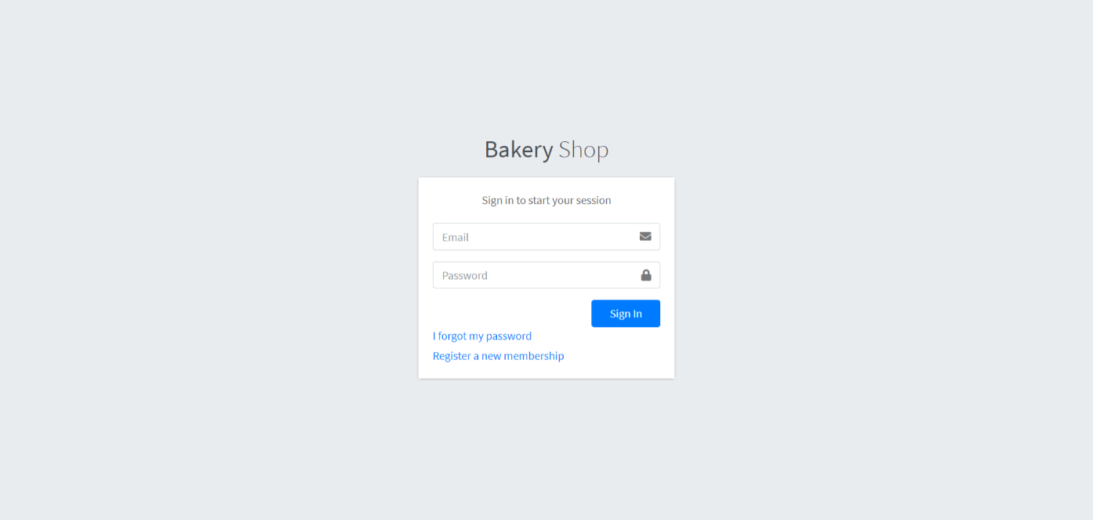

1. **Registration:**

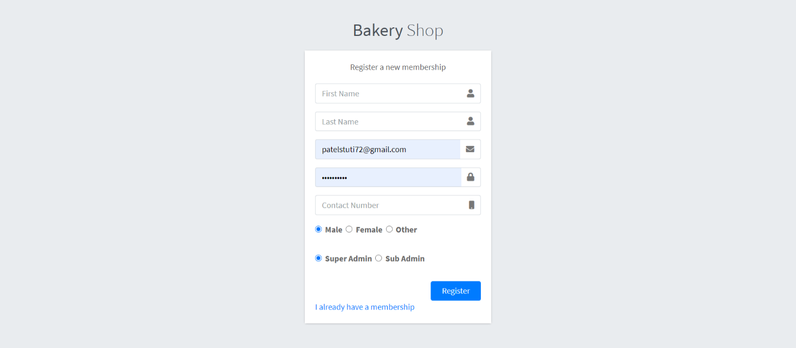

1. Dashboard:

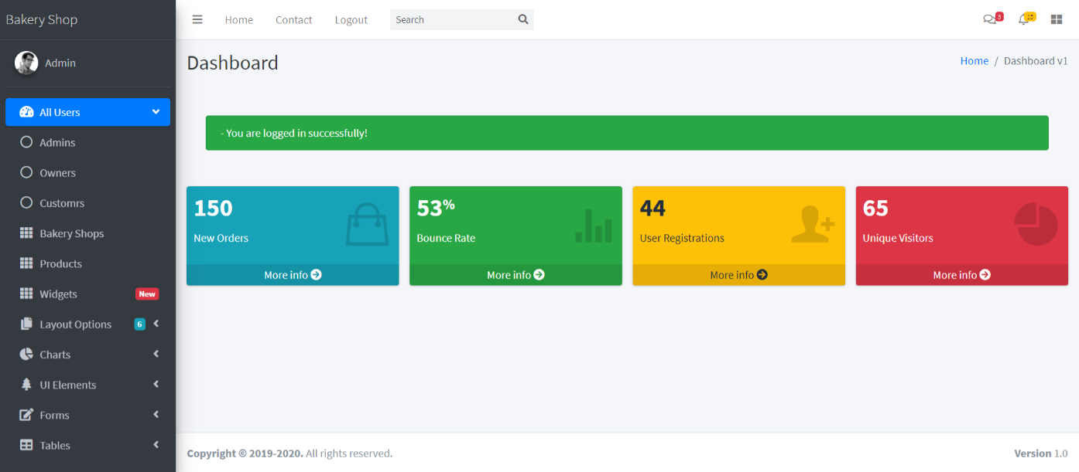

1. **Admin list:**

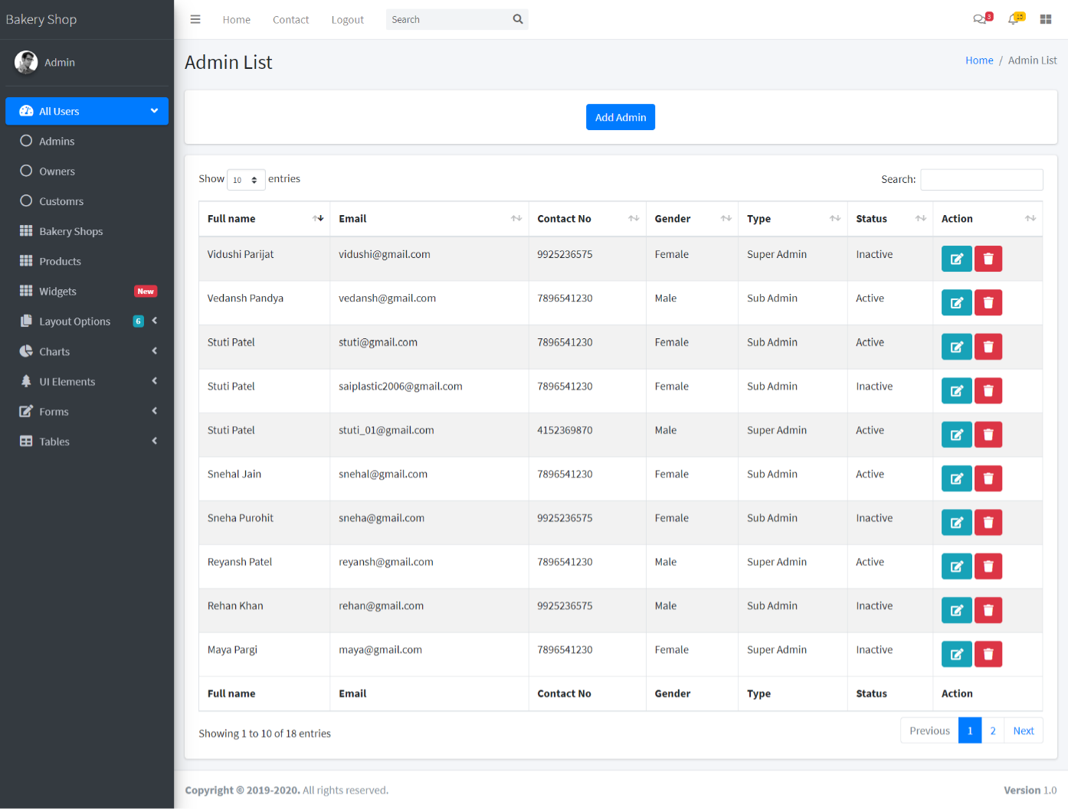

**9.2 Users Site:**

1. **Home:**

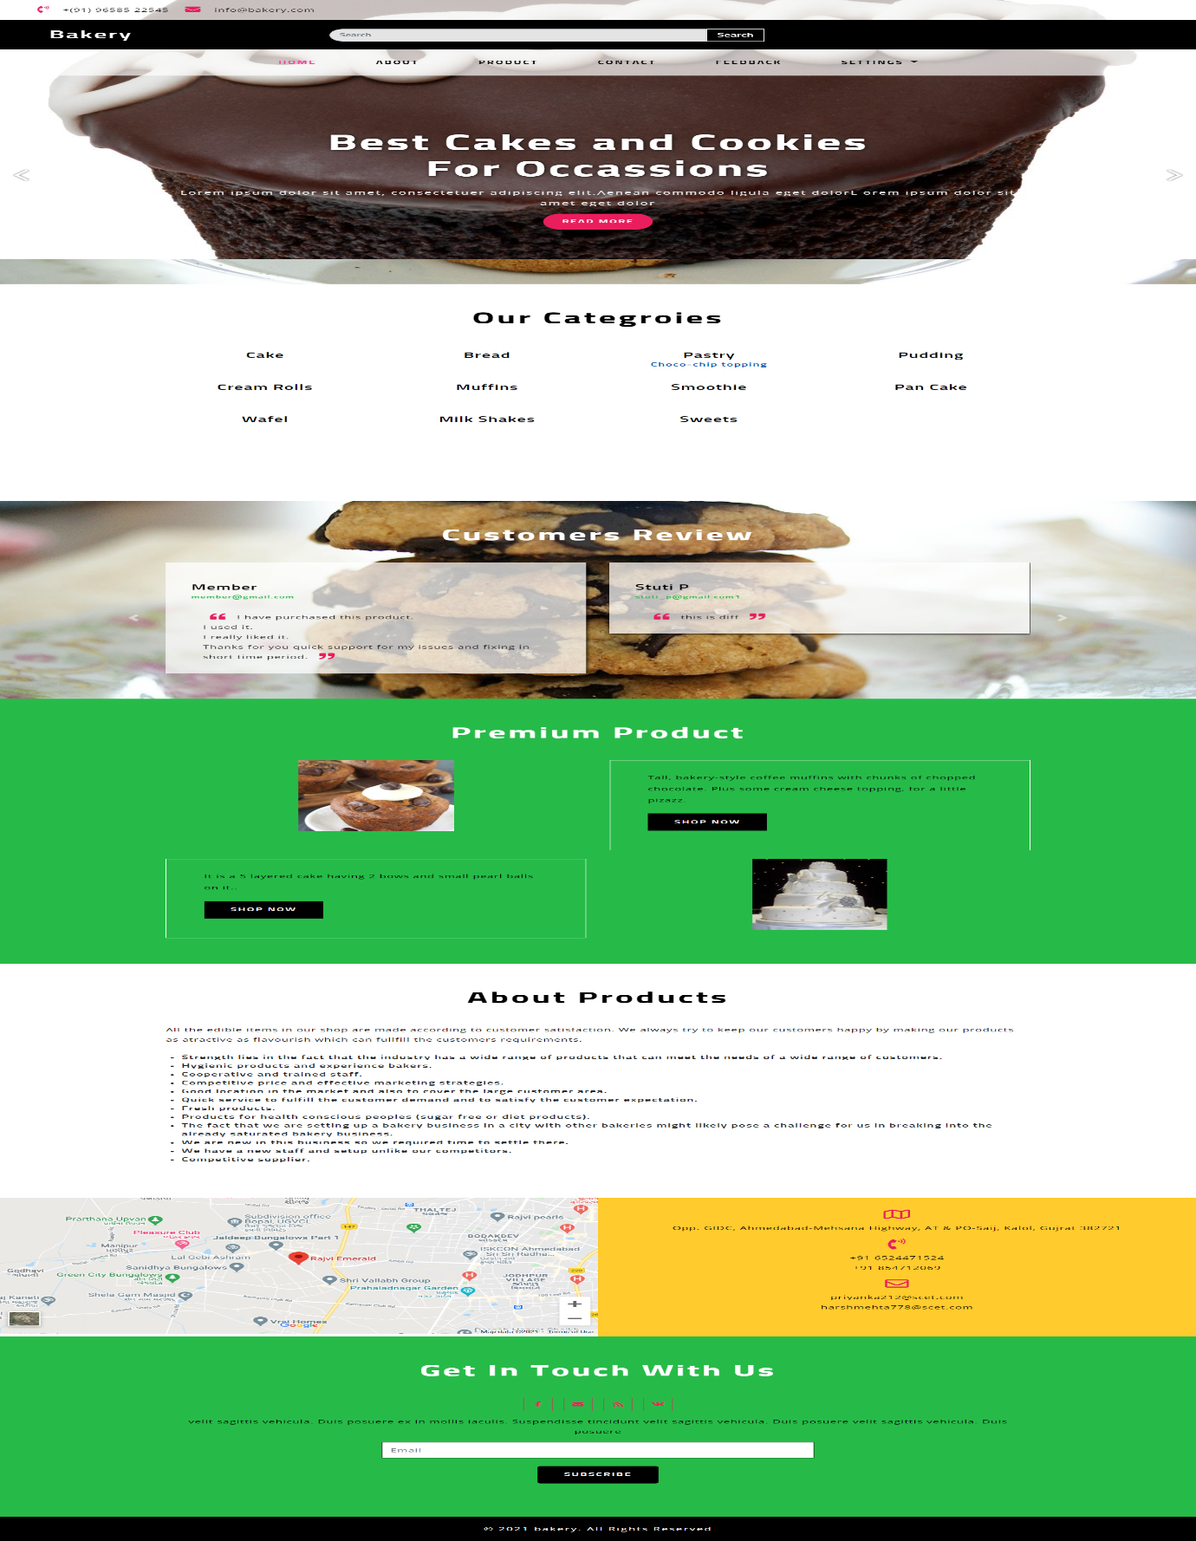

1. **About us:**

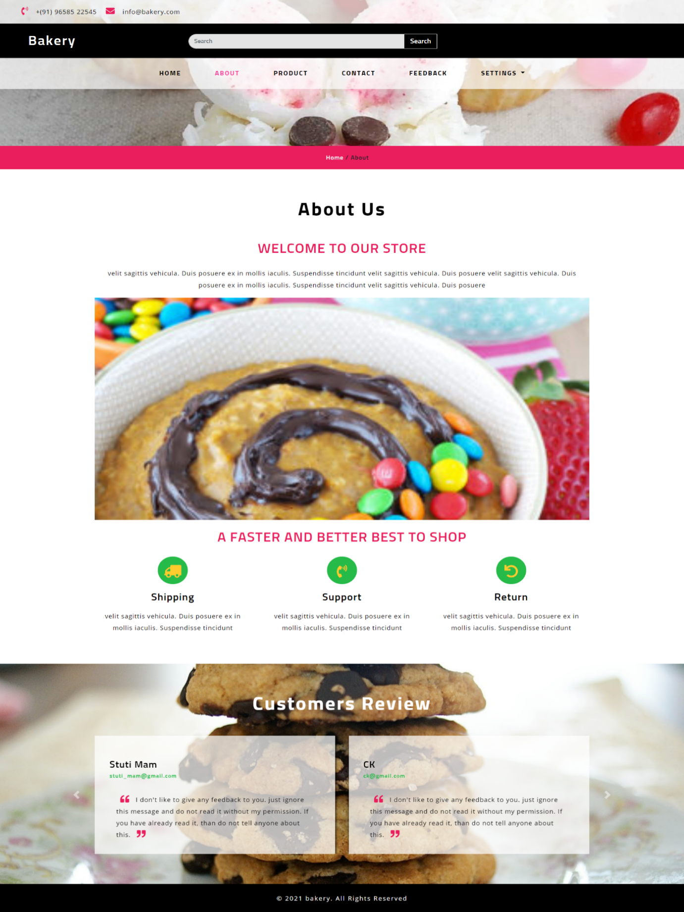

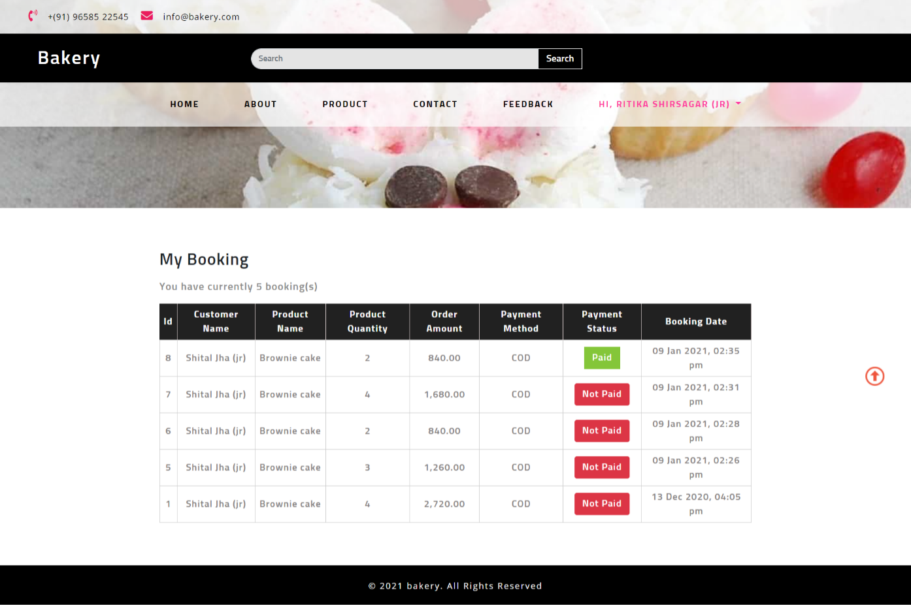

|  |  |  |  |
| --- | --- | --- | --- |
| **Sr. No.** | **CO statement** | **Marks % weightage** | **Chapter No.** |
| CO-1 | Undertake problem identification, formulation and solution | 20% | * **CHAPTER 1** INTRODUCTION |
| CO-2 | Design engineering solutions to complex problems utilising a systematic approach and team work | 30% | * **CHAPTER 2** SYSTEM REQUIREMENTS * **CHAPTER 3** DAILY TASK |
| CO-3 | Communicate with engineers and the community at large in written and oral forms | 20% | * **CHAPTER 6** SYSTEM DESIGN * **CHAPTER 10** ADVANTAGES * **CHAPTER 11** CONCLUSION AND FUTURE ENHANCEMENT |
| CO-4 | Demonstrate the knowledge and understanding of engineering and management principle and apply it to assigned project | 30% | * **CHAPTER 4** FRONT END OF SYSTEM * **CHAPTER 5** BACK END OF SYSTEM * **CHAPTER 6** SYSTEM DESIGN * **CHAPTER 7** DATA DICTIONARY * **CHAPTER 8** TESTING |

**CHAPTER: 12**

**BIBLIOGRAPHY**

**12.1 Course Outcome**

**12.2 Books**

**12.3 Web Reference**

**12.2 Books:**

* **Fundamental of software Engineering**
  + Author: Rajib Mall
* **The Joy of PHP Programming**
  + **Author:**  Alan Forbes
* [**Programming PHP: Creating Dynamic Web Pages**](http://geni.us/rZS9)
  + **Author:** Kevin Tatroe, Peter MacIntyre & Rasmus Lerdorf Foreword by Michael Bourque
* **SQL Server Database**
  + Author: Mr.Gaurav Desani
* **System Analysis and Design** 
  + Author: Mr. Mitul Modi
  + Mr. Hemant Oza

**12.3 Web Reference:**

* **W3Schools. "JavaScript Tutorial." [Online].**
  + Available: <https://www.w3schools.com/js/default.asp>. [Accessed: February 7, 2023].
* **Javatpoint. “Node JS Tutorial.”** 
  + [Online] Available: <https://www.javatpoint.com/nodejs-tutorial>. [Accessed: February 21, 2023].
* **W3Schools. "CSS Tutorial." [Online].** 
  + Available: <https://www.w3schools.com/css/default.asp>.. [Accessed: March 15, 2023].
* **Free Code Camp. "Learn to code — for free." [Online].**
  + Available: <https://www.freecodecamp.org/> [Accessed: April 30, 2023].
* **Stack Overflow.** **"Where Developers Learn, Share, & Build Careers." [Online].** 
  + Available: <https://stackoverflow.com/> [Accessed: May 1, 2023]